Case Study 89: University Hostel Room Allocation

1. Problem Statement
Develop a Python program to allocate hostel rooms to university students based on room availability. The program should accept student details, check whether rooms are available, allocate a room if available, and display the allocation details. If no rooms are available, the program should display an appropriate message.

2. Objectives
To allocate hostel rooms to students efficiently.
To check room availability before allocation.
To store and display student details.
To prevent allocation when all rooms are occupied.
To display the allocated room number and student information.

3. Assumptions
The hostel has a fixed number of rooms.
Each room can accommodate only one student.
Every student has a unique roll number.
Student names and roll numbers are entered by the user.
Rooms are allocated in sequential order.
If all rooms are occupied, new allocations are not allowed.

4. Algorithm
- Start the program.
- Set the total number of hostel rooms.
- Initialize an empty list to store student details.
- Display the menu to allocate a room, view allocations, or exit.
- If the user selects room allocation, enter the student's roll number and name.
- Check whether the roll number already exists.
- Check whether any rooms are available.
- If a room is available, assign the next room number and store the student details.
- Otherwise, display “No rooms available.”
- If the user selects view allocations, display all allocated rooms and student details.
- Repeat until the user chooses to exit.
- Stop the program.

5. Flowchart

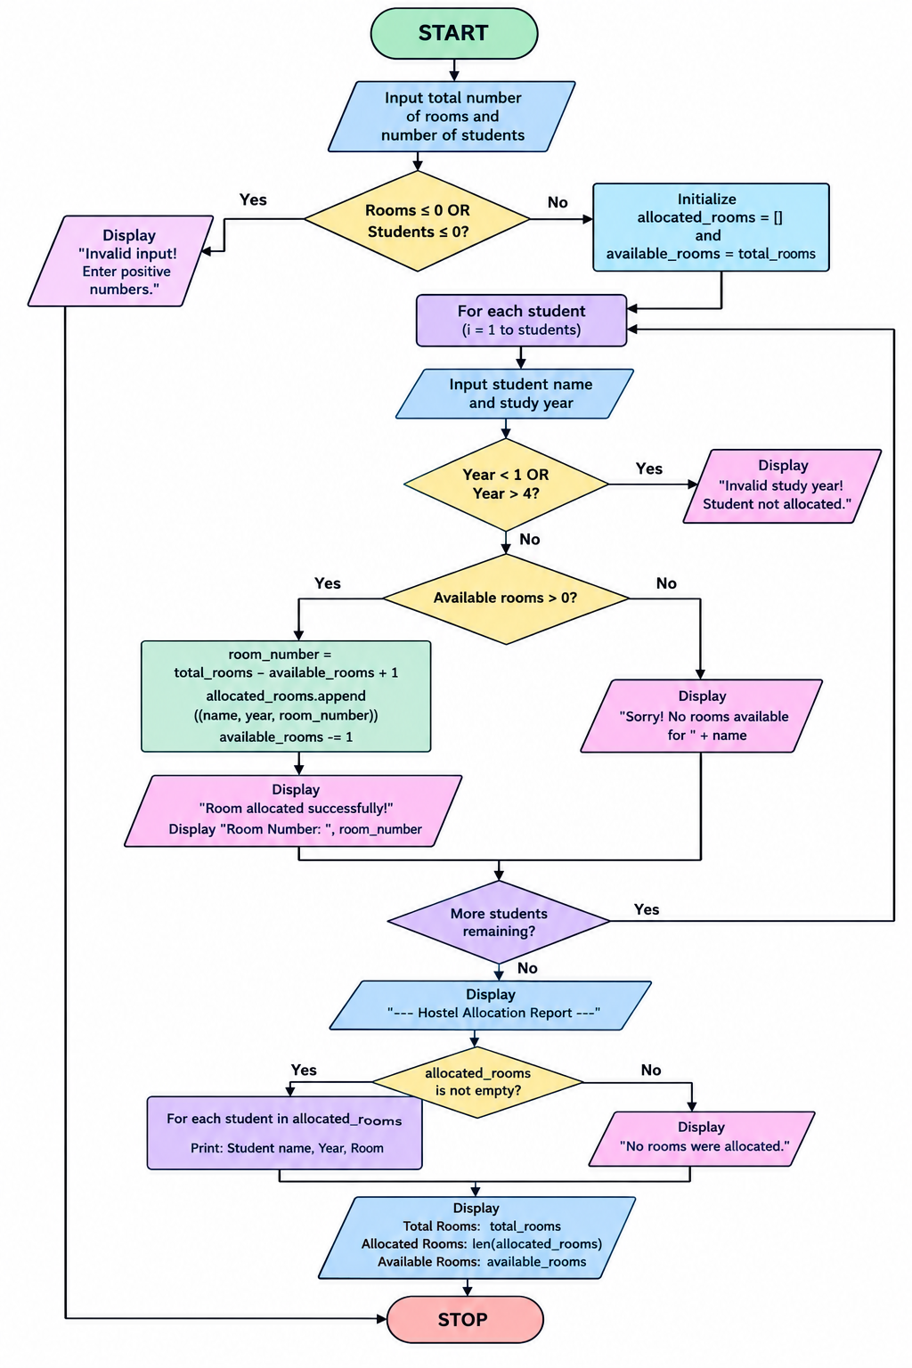

6. Pseudocode
START

SET total_rooms = 3
CREATE empty list allocations

WHILE True:
DISPLAY menu
INPUT choice

IF choice = 1:
INPUT roll_number
INPUT student_name

IF roll_number already exists:
DISPLAY "Student already allocated a room"

ELSE IF number of allocations < total_rooms:
SET room_number = number of allocations + 1
STORE roll_number, student_name, room_number
DISPLAY "Room allocated successfully"

ELSE:
DISPLAY "No rooms available"

ELSE IF choice = 2:
DISPLAY all allocated room details

ELSE IF choice = 3:
BREAK

ELSE:
DISPLAY "Invalid choice"

STOP

7. Test Cases
Assume the hostel has 3 rooms.
Test case | Input / condition | Expected output
1 | Allocate room to student Ravi, roll no. 101 | Room 1 allocated successfully
2 | Allocate room to student Sita, roll no. 102 | Room 2 allocated successfully
3 | Allocate room to student Arun, roll no. 103 | Room 3 allocated successfully
4 | Allocate a room to another student | No rooms available
5 | Enter an existing roll number | Student already allocated a room
6 | Select an invalid menu option | Invalid choice

8. Output

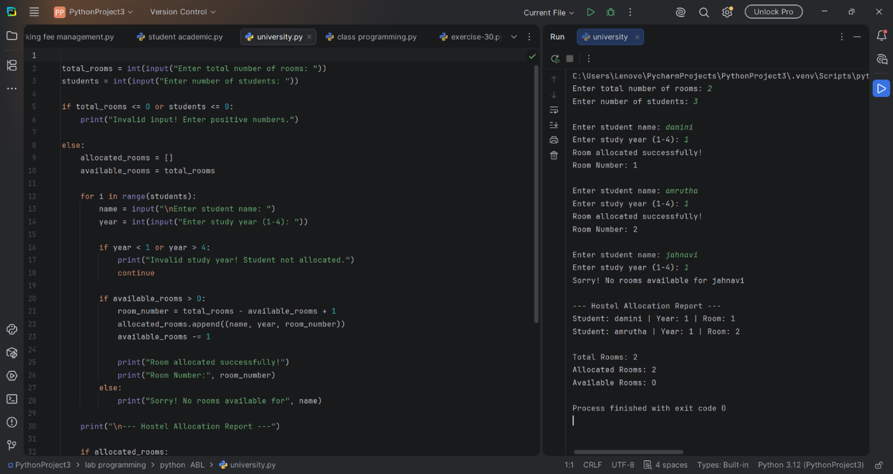

9. Conclusion
The University Hostel Room Allocation program provides a simple and efficient method for managing hostel rooms. It checks room availability, prevents duplicate student allocations, assigns rooms, and displays student details. This program demonstrates the practical use of Python lists, loops, conditional statements, and user input in solving a real-world problem.

